DOBIE RANCH RESCUE/AHSCFPRI Application Form For Adoption
Name of Applicant |  |  |  |  |  |  |  | Name of Spouse
Occupation |  |  |  |  |  |  |  | Occupation
Address |  |  |  |  |  |  |  | Phone
City |  |  | Zip |  |  |  |  | Primary E-mail
 |  |  | Other |  |  |  |  | FAX #
Primary Address |  |  |  |  |  |  |  | Dr. License #
Dr. License # |  |  |  |  |  |  |  | How long at this address?
Rent or Own? House □ Mobile Home □ Apartment □ Condo □ |  |  |  |  |  |  |  | Landlord’s Phone #
Does your landlord allow pets? Yes □ No □ |  |  |  |  |  | Property Owner’s name
Other Occupants? | Number of Adults? |  |  |  |  | Children? |  |  | Ages?
Do you have a yard? Yes □ No □ |  | Type of fence? |  |  |  |  |  |  | Size of yard?

Current Pets in Your Household – Use back of sheet if necessary
Breed | Name |  | Sex |  |  |  | Years Owned? |  |  | Spayed or neutered?
 |  |  | M □ F □ |  |  |  |  |  |  | Yes □ No □
 |  |  | M □ F □ |  |  |  |  |  |  | Yes □ No □
 |  |  | M □ F □ |  |  |  |  |  |  | Yes □ No □
 |  |  | M □ F □ |  |  |  |  |  |  | Yes □ No □
 |  |  | M □ F □ |  |  |  |  |  |  | Yes □ No □
 |  |  | M □ F □ |  |  |  |  |  |  | Yes □ No □
All dogs on Heartworm prevention? Yes □ No □ |  |  |  | If not, please explain:
All pet current on vaccinations? Yes □ No □ |  |  |  | If not, please explain:
Do you have a veterinarian? Yes □ No □ |  |  |  | Name of Veterinarian & Practice?
Veterinarian’s Phone #
Address of veterinary practice
May DRR contact your veterinarian to verify the above information? Yes □ No □

Home Pet Care Plans
Have you owned a Doberman before? Yes □ No □ |  |  | Do you know the temperament & characteristics of a Doberman? Yes □ No □
Why do you want to adopt a Doberman?
Where will the Doberman be kept during the day? |  |  |  |  | At night?
Where will the Doberman be kept when you’re not at home?
On the average, how many hours will the Doberman be left alone?
What will you do with your Doberman if you move?
How much money do you plan to spend on your Doberman per year?
Will you obedience train your Doberman? Yes □ No □ |  |  |  |  | Do you plan to crate train your Doberman? Yes □ No □
Do you plan to exercise your Doberman? Yes □ No □ |  |  |  |  | Will you accept a Doberman with special needs? Yes □ No □
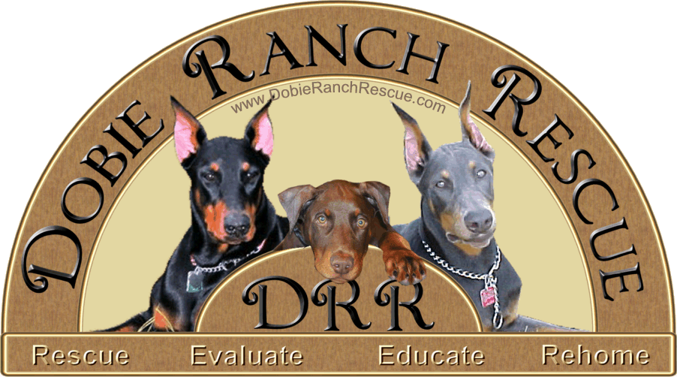
Do you own any of the following? Dog Crate □ Dog Door □ Dog Run □

Pet History – Use back of sheet if necessary
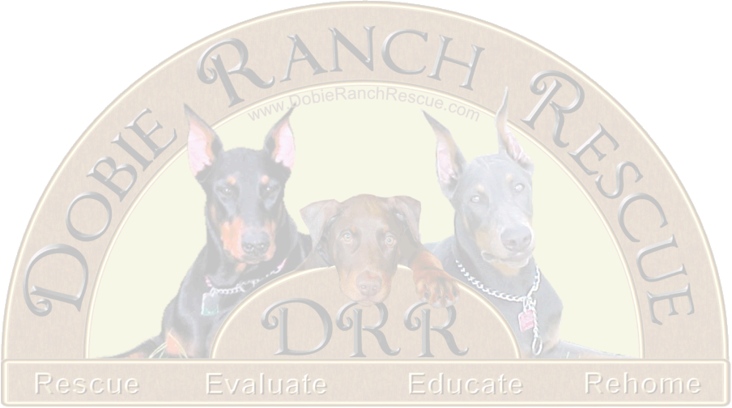
If you have owned any pet within the last 3 three years, please fill out the section below. Please be as accurate as possible.
Breed | Name | Sex | Years Owned? Status? | Spayed or neutered?
 |  | M □ F □ |  | Yes □ No □
 |  | M □ F □ |  | Yes □ No □
 |  | M □ F □ |  | Yes □ No □
 |  | M □ F □ |  | Yes □ No □
 |  | M □ F □ |  | Yes □ No □
 |  | M □ F □ |  | Yes □ No □
Comments:
Have you ever been charged with an animal control violation? Yes □ No □
Explain violation:
Are all household members aware of the intent to adopt? Yes □ No □
May a representative of DRR visit your home? Yes □ No □

DRR RESERVES THE RIGHT TO REFUSE ADOPTION FOR ANY REASON
Applicant’s Signature: Date:

The completed application may be submitted by:

2. Fax to:

Dobie Ranch Rescue/AHSCFPRI
ATTN: Diane DeSantis
352-563-1253
3. Mail to:

Dobie Ranch Rescue/AHSCFPRI
ATTN: Diane DeSantis
8087 N Lazy Trail
Crystal River, FL 34428

1. Email to:

mailto:diane@dobieranchrescue.com
or
or

