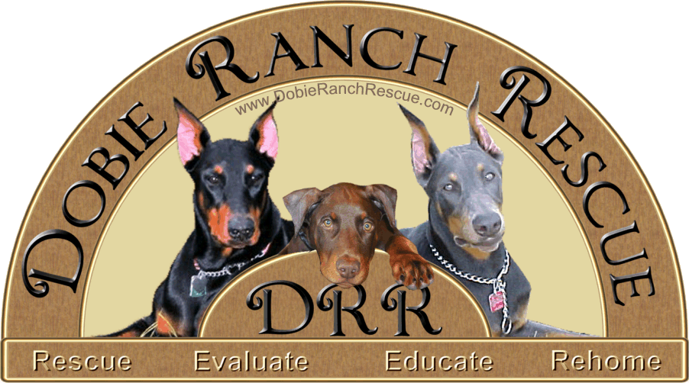

Foster Volunteer Application

Foster Volunteer Application

Name:____________________________________________________________
Address:________________________________________________________________________________________
Home Phone:___________________ Cell Phone:___________________ E-mail:______________________________
Why would you like to participate in this program?

Please list the current animals in your household:

Are your pets good with other animals? ___________________
If you have cats, do you keep them indoors or do you let them outside?
________________________________________________________
If you have dogs, do you keep them primarily indoors or outside?
________________________________________________________
Do you have a fenced yard? Yes No
Please indicate your housing status:
__ Rent an apartment
__ Rent a house
__ Own a house or condo
__ Live with parents

If you are renting, please provide your landlord's name and phone number:
________________________________________________________
Do you work outside of the home? Yes No
How many hours a day are your pets home alone? ______________
Where are they kept when you are away from home? ____________
Do you have children in your household? Yes No If yes, how many? _________
Please list their ages: ______________________________________
Your veterinarian's name: __________________________________
Telephone number: _______________________________________

Please list two unrelated personal references whom we may contact:

Personal reference #1: ____________________________________
Phone number: _________________________________________
Your relationship: _______________________________________

Personal reference #2: ___________________________________
Phone number: _________________________________________
Your relationship: _______________________________________

Please make any additional comments below:

FOSTER VOLUNTEER AGREEMENT AND RELEASE:

I, ________________________________ am requesting a foster/volunteer position with the Dobie Rescue Ranch (DRR), a division of A Humane Society of Central Florida Pet Rescue, Inc. (AHSCFPRI). I agree to read and follow the rules and guidelines of the organization. I agree not to hold the organization, any director, employee, board member, or any individual personally or otherwise responsible in the event that I sustain personal, financial, emotional, or property loss/damage while serving the organization. I agree to follow the supervision of all persons involved in foster/volunteer management. I understand that, as a foster/volunteer, I am an important representative of the DRR/AHSCFPRI and must do my best to represent this organization in a manner that is consistent with its articles, bylaws, guidelines, and philosophies. I am fully aware of the nature and purpose of the activities of DRR/AHSCFPRI. I acknowledge that these activities are potentially risky because animals may carry transmittable diseases, bite or scratch and I voluntarily accept any risks involved. I further agree to hold DRR/AHSCFPRI harmless from any liability due to any injury or illness incurred by me, my family, or my pets, during any foster/volunteer assignment. I understand that all foster pets are the property of DRR/AHSCFPRI and I will return my un-adopted fosters to the representatives if and when requested by DRR Director, Diane DeSantis, or her assignee.

I have read and understand this document; I freely consent to its provisions.

Printed Name __________________________________Witness___________________________________

Signature _______________________________________ Date _________________

